DAY 3 PROGRAMS

Name:-OMKAR

Reg.No:-192111134

13. Write a C program to implement single-level directory system. In which all the files are placed in one directory and there are no sub directories.

Test Case: Create one directory with the name of CSE and Add 3 files(A,B,C) in to that directory

Program:-

#include <stdio.h>

#include <stdlib.h>

int main() {

system("mkdir CSE");

FILE *fileA = fopen("CSE/A", "w");

FILE *fileB = fopen("CSE/B", "w");

FILE *fileC = fopen("CSE/C", "w");

if (fileA == NULL || fileB == NULL || fileC == NULL) {

printf("Error: Unable to create files\n");

return 1;

}

fprintf(fileA, "This is file A\n");

fprintf(fileB, "This is file B\n");

fprintf(fileC, "This is file C\n");

fclose(fileA);

fclose(fileB);

fclose(fileC);

printf("Directory 'CSE' created with 3 files: A, B, and C\n");

return 0;

}

Output:-

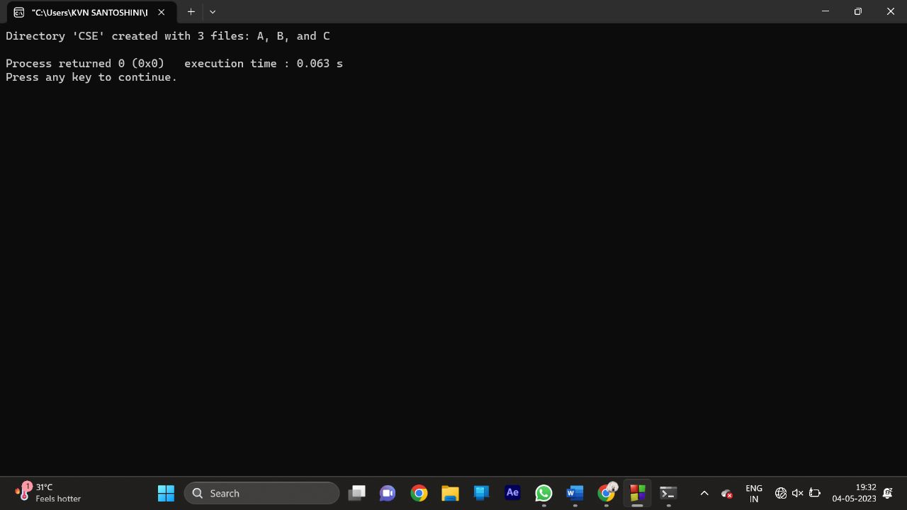

14. Write a C program to illustrate the page replacement method where the page which is not in demand for the longest future time is replaced by the new page and determine the number of page faults for the following

test case: No. of page frames: 3; Page reference sequence 7,0,1,2,0,3,0,4,2,3,0,3,2,1,2,0,1,7,0 and 1.

Program:-

#include <stdio.h>

#define MAX_FRAMES 3

int main()

{

int frames[MAX_FRAMES], pages[MAX_FRAMES], page_faults = 0;

int page_reference[] = {7,0,1,2,0,3,0,4,2,3,0,3,2,1,2,0,1,7,0,1};

int num_pages = sizeof(page_reference)/sizeof(page_reference[0]);

int i, j, k, max_future_distance, page_to_replace;

for(i = 0; i < MAX_FRAMES; i++)

{

frames[i] = -1;

pages[i] = -1;

}

for(i = 0; i < num_pages; i++)

{

int page_found = 0;

int page = page_reference[i];

for(j = 0; j < MAX_FRAMES; j++)

{

if(frames[j] == page)

{

page_found = 1;

break;

}

}

if(page_found == 0)

{

for(j = 0; j < MAX_FRAMES; j++)

{

int page_exists = 0;

int future_distance = 0;

for(k = i + 1; k < num_pages; k++)

{

if(frames[j] == page_reference[k])

{

page_exists = 1;

future_distance = k - i;

break;

}

}

if(page_exists == 0)

{

page_faults++;

frames[j] = page;

break;

}

if(future_distance > max_future_distance)

{

max_future_distance = future_distance;

page_to_replace = j;

}

}

page_faults++;

frames[page_to_replace] = page;

}

}

printf("Number of Page Faults: %d", page_faults);

return 0;

}

OUTPUT:-

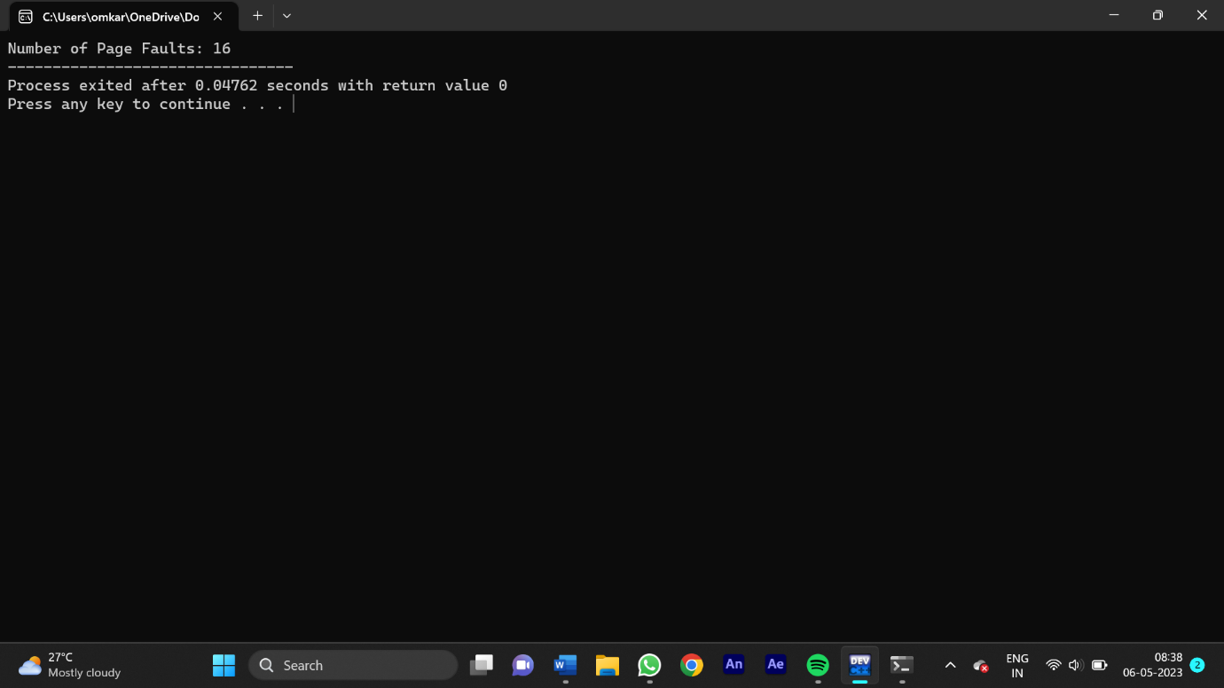

15.Write a C program to simulate FCFS disk scheduling algorithms and execute your program and find out and print the average head movement for the following test case.

No of tracks:9; Track position:55 58 60 70 18 90 150 160 184

Program:-

#include <stdio.h>

#include <stdlib.h>

#include <math.h>

#define MAX_REQUESTS 1000

int main() {

int requests[MAX_REQUESTS];

int num_requests;

int head_pos, total_head_movement;

float avg_head_movement;

printf("Enter the number of disk requests: ");

scanf("%d", &num_requests);

printf("Enter the disk requests:\n");

for (int i = 0; i < num_requests; i++) {

scanf("%d", &requests[i]);

}

printf("Enter the initial head position: ");

scanf("%d", &head_pos);

total_head_movement = abs(head_pos - requests[0]);

for (int i = 1; i < num_requests; i++) {

total_head_movement += abs(requests[i] - requests[i-1]);

}

avg_head_movement = (float)total_head_movement / num_requests;

printf("Total head movement: %d\n", total_head_movement);

printf("Average head movement: %.2f\n", avg_head_movement);

return 0;

}

Output:-

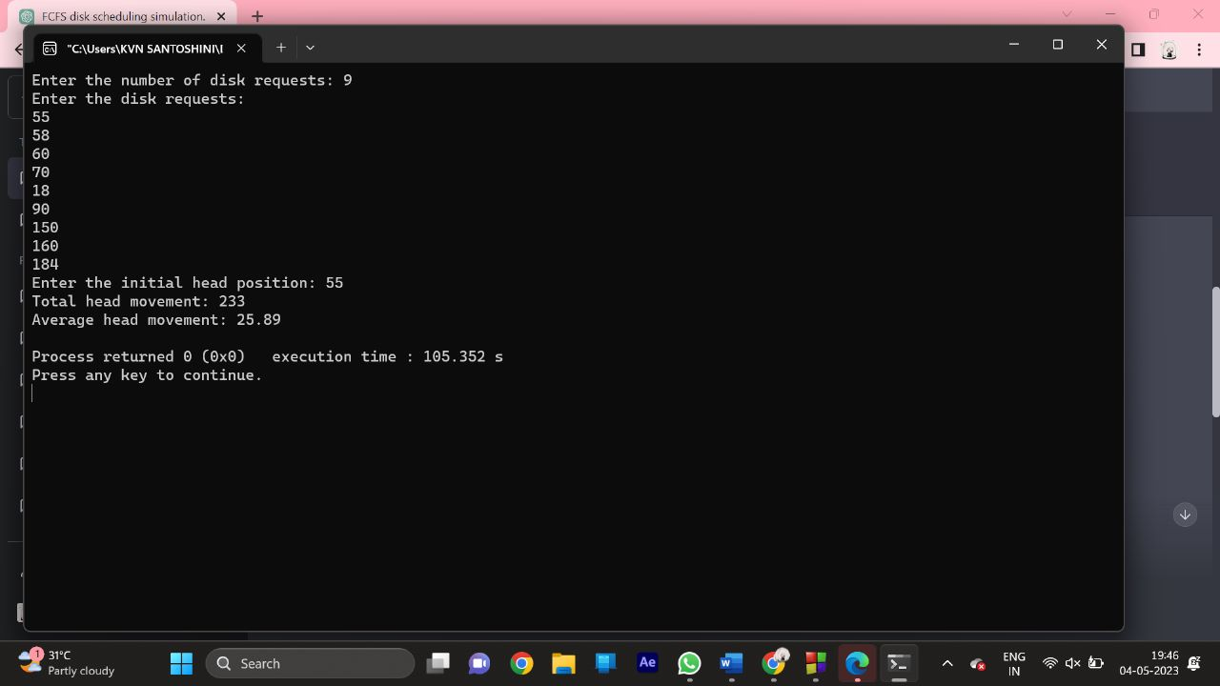

16. Write a program to compute the average waiting time and average turnaround time based on First Come First Serve for the following process with the given CPU burst times, (and the assumption that all jobs arrive at the same time.)

Process Burst Time

P1 10

P2 15

P3 25

Program:-

#include <stdio.h>

#define MAX_PROCESSES 100

int main() {

int burst_times[MAX_PROCESSES];

int num_processes;

int waiting_times[MAX_PROCESSES];

int turnaround_times[MAX_PROCESSES];

int total_waiting_time = 0, total_turnaround_time = 0;

printf("Enter the number of processes: ");

scanf("%d", &num_processes);

printf("Enter the burst times:\n");

for (int i = 0; i < num_processes; i++) {

scanf("%d", &burst_times[i]);

}

waiting_times[0] = 0;

turnaround_times[0] = burst_times[0];

for (int i = 1; i < num_processes; i++) {

waiting_times[i] = waiting_times[i-1] + burst_times[i-1];

turnaround_times[i] = waiting_times[i] + burst_times[i];

}

for (int i = 0; i < num_processes; i++) {

total_waiting_time += waiting_times[i];

total_turnaround_time += turnaround_times[i];

}

float avg_waiting_time = (float)total_waiting_time / num_processes;

float avg_turnaround_time = (float)total_turnaround_time / num_processes;

printf("Average waiting time: %.2f\n", avg_waiting_time);

printf("Average turnaround time: %.2f\n", avg_turnaround_time);

return 0;

}

Output:-

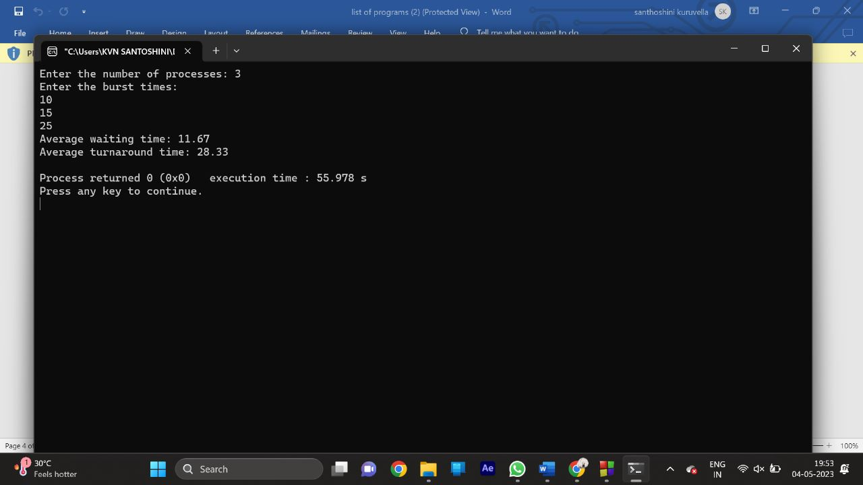

17. Write a program to compute the average waiting time and average turnaround time based on Round Robin scheduling for the following process with the given CPU burst times and quantum time slots 4 ms, ( and the assumption that all jobs arrive at the same time.)

Process Burst Time

P1 24

P2 3

P3 3

Program:-

#include <stdio.h>

#define MAX_PROCESSES 100

int main() {

int burst_times[MAX_PROCESSES];

int num_processes;

int waiting_times[MAX_PROCESSES];

int turnaround_times[MAX_PROCESSES];

int remaining_burst_times[MAX_PROCESSES];

int quantum = 4;

int time = 0, total_waiting_time = 0, total_turnaround_time = 0;

int completed_processes = 0;

printf("Enter the number of processes: ");

scanf("%d", &num_processes);

printf("Enter the burst times:\n");

for (int i = 0; i < num_processes; i++) {

scanf("%d", &burst_times[i]);

remaining_burst_times[i] = burst_times[i];

}

while (completed_processes < num_processes) {

for (int i = 0; i < num_processes; i++) {

if (remaining_burst_times[i] > 0) {

if (remaining_burst_times[i] <= quantum) {

time += remaining_burst_times[i];

waiting_times[i] = time - burst_times[i];

turnaround_times[i] = time;

remaining_burst_times[i] = 0;

completed_processes++;

} else {

time += quantum;

remaining_burst_times[i] -= quantum;

}

}

}

}

for (int i = 0; i < num_processes; i++) {

total_waiting_time += waiting_times[i];

total_turnaround_time += turnaround_times[i];

}

float avg_waiting_time = (float)total_waiting_time / num_processes;

float avg_turnaround_time = (float)total_turnaround_time / num_processes;

printf("Average waiting time: %.2f\n", avg_waiting_time);

printf("Average turnaround time: %.2f\n", avg_turnaround_time);

return 0;

}

Output:-

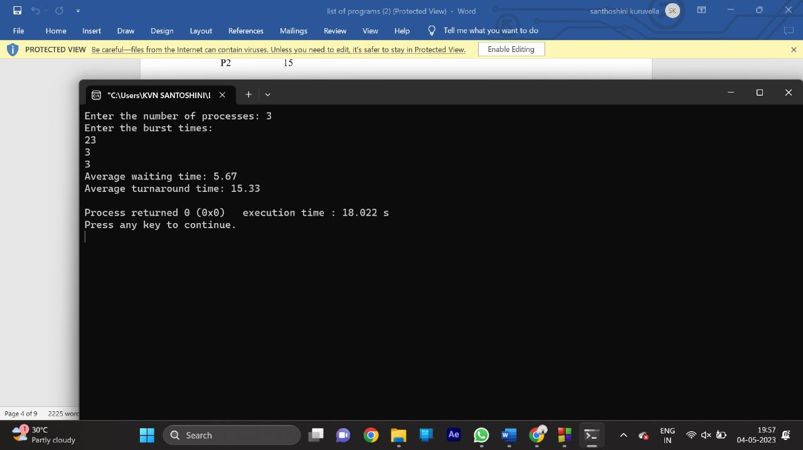

18. Write a program for solving the producer consumer problem with the following scenario: The producer should produce data only when the buffer is not full. Data can only be consumed by the consumer if and only if the memory buffer is not empty.

Test Case:

Buffer Size: 3

Consume an item in the beginning and show that the buffer is EMPTY

Produce 4 items and show that the buffer is FULL

Program:-

#include <stdio.h>

#include <stdlib.h>

#include <pthread.h>

#include <semaphore.h>

#define BUFFER_SIZE 10

int buffer[BUFFER_SIZE];

int producer_index = 0, consumer_index = 0;

sem_t empty;

sem_t full;

pthread_mutex_t mutex;

void *producer(void *arg) {

int data = 1;

while (1) {

sleep(1);

printf("Producer produced data: %d\n", data);

sem_wait(&empty);

pthread_mutex_lock(&mutex);

buffer[producer_index] = data;

producer_index = (producer_index + 1) % BUFFER_SIZE;

pthread_mutex_unlock(&mutex);

sem_post(&full);

data++;

}

}

void *consumer(void *arg) {

while (1) {

sem_wait(&full);

pthread_mutex_lock(&mutex);

int data = buffer[consumer_index];

printf("Consumer consumed data: %d\n", data);

consumer_index = (consumer_index + 1) % BUFFER_SIZE;

pthread_mutex_unlock(&mutex);

sem_post(&empty);

sleep(2);

}

}

int main() {

sem_init(&empty, 0, BUFFER_SIZE);

sem_init(&full, 0, 0);

pthread_mutex_init(&mutex, NULL);

pthread_t producer_thread, consumer_thread;

pthread_create(&producer_thread, NULL, producer, NULL);

pthread_create(&consumer_thread, NULL, consumer, NULL);

pthread_join(producer_thread, NULL);

pthread_join(consumer_thread, NULL);

sem_destroy(&empty);

sem_destroy(&full);

pthread_mutex_destroy(&mutex);

return 0;

}

Output:-

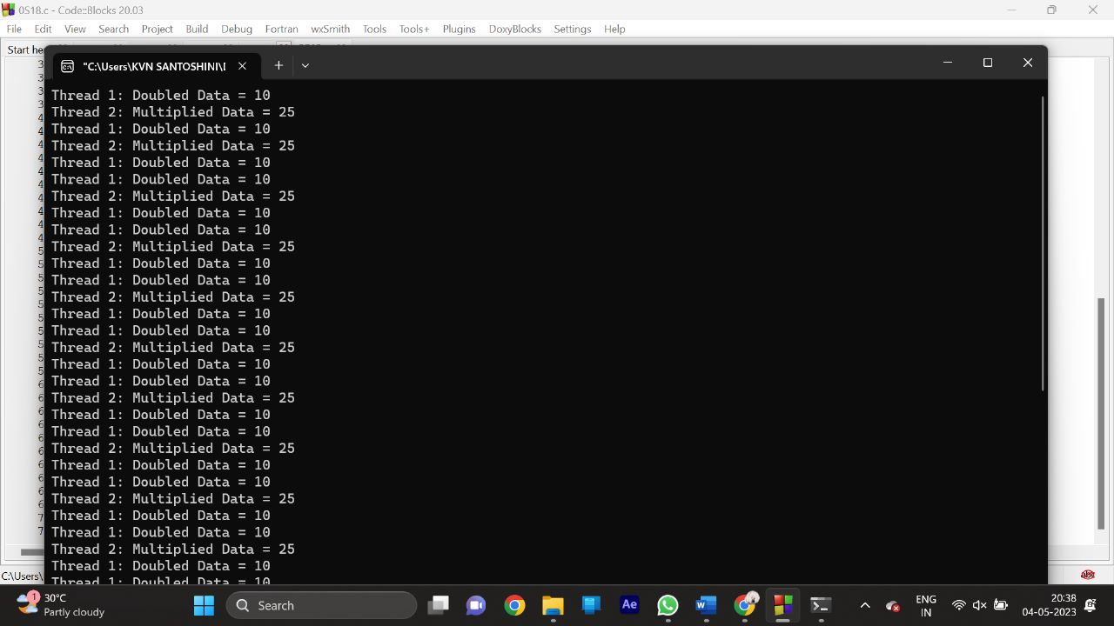

19. Write a C program to create two threads to access shared memory which is an integer in a synchronized fashion using semaphore. In the first thread print the doubled the integer data after reading from the shared memory. In the second thread, print the five times of the integer data after reading from the shared memory

Program:-

#include <stdio.h>

#include <stdlib.h>

#include <pthread.h>

#include <semaphore.h>

int shared_data = 5;

sem_t mutex;

void *thread1(void *arg) {

while (1) {

sem_wait(&mutex);

int data = shared_data;

data = data * 2;

printf("Thread 1: Doubled Data = %d\n", data);

sem_post(&mutex);

sleep(1);

}

}

void *thread2(void *arg) {

while (1) {

sem_wait(&mutex);

int data = shared_data;

data = data * 5;

printf("Thread 2: Multiplied Data = %d\n", data);

sem_post(&mutex);

sleep(2);

}

}

int main() {

sem_init(&mutex, 0, 1);

pthread_t tid1, tid2;

pthread_create(&tid1, NULL, thread1, NULL);

pthread_create(&tid2, NULL, thread2, NULL);

pthread_join(tid1, NULL);

pthread_join(tid2, NULL);

sem_destroy(&mutex);

return 0;

}

Output:-



20. Write a C program to implement the worst-fit algorithm and allocate the memory block to each process.

Test Case:

Memory partitions: 300 KB, 600 KB, 350 KB, 200 KB, 750 KB, and 125 KB (in order),

Show the outcome for the test case with the worst-fit algorithms to place processes of size 115 KB, 500 KB, 358 KB, 200 KB, and 375 KB (in order)

Program:-

#include <stdio.h>

#define MAX_BLOCKS 10

#define MAX_PROCESSES 10

int main() {

int blocks[MAX_BLOCKS], processes[MAX_PROCESSES];

int num_blocks, num_processes, i, j;

printf("Enter the number of memory blocks: ");

scanf("%d", &num_blocks);

printf("Enter the size of each memory block:\n");

for (i = 0; i < num_blocks; i++) {

printf("Block %d: ", i);

scanf("%d", &blocks[i]);

}

printf("Enter the number of processes: ");

scanf("%d", &num_processes);

printf("Enter the size of each process:\n");

for (i = 0; i < num_processes; i++) {

printf("Process %d: ", i);

scanf("%d", &processes[i]);

}

int allocation[MAX_PROCESSES];

for (i = 0; i < MAX_PROCESSES; i++) {

allocation[i] = -1;

}

for (i = 0; i < num_processes; i++) {

int worst_index = -1;

for (j = 0; j < num_blocks; j++) {

if (blocks[j] >= processes[i]) {

if (worst_index == -1 || blocks[j] > blocks[worst_index]) {

worst_index = j;

}

}

}

if (worst_index != -1) {

allocation[i] = worst_index;

blocks[worst_index] -= processes[i];

}

}

printf("\nProcess\tProcess Size\tBlock\tBlock Size\n");

for (i = 0; i < num_processes; i++) {

printf("%d\t%d\t\t", i, processes[i]);

if (allocation[i] != -1) {

printf("%d\t%d\n", allocation[i], blocks[allocation[i]]);

} else {

printf("Not Allocated\n");

}

}

return 0;

}

Output:-

